# CHAPTER 1

## Background

# INTRODUCTION

Brain tumors are among the most dangerous types of cancer due to their location in the central nervous system, which controls all vital body functions. Diagnosing brain tumors is particularly challenging because they can vary widely in type, shape, size, and location. Early and accurate diagnosis is essential to decide on the right treatment plan—surgery, radiotherapy, or chemotherapy—and significantly influences patient survival rates.

In recent years, **Deep Learning (DL)** has shown great promise in medical image analysis. DL models, particularly **Convolutional Neural Networks (CNNs)**, can automatically learn complex patterns from large image datasets. **Reinforcement Learning (RL)**, on the other hand, is a progressive AI approach that learns by interacting with an environment and making sequential decisions to maximize rewards.

Combining DL with RL, known as **Deep Reinforcement Learning (DRL)**, enables a system that not only learns to classify but also adapts and improves over time based on feedback.

## Problem Identification

Most previous research in brain tumor classification has used supervised learning, which requires large, labeled datasets. However, supervised methods are limited in dynamic environments and cannot adapt on the fly. Also, traditional image enhancement methods such as Histogram Equalization (HE) and Contrast- Limited Adaptive Histogram Equalization (CLAHE) often introduce artifacts or fail to improve contrast effectively.Additionally, existing CNN architectures like GoogleNet or ResNet alone suffer from limitations such as inadequate depth (in GoogleNet) or poor multiscale feature extraction (in ResNet), which can affect classification accuracy. Hence, there is a need for a more adaptable, precise, and automated system for **brain tumor categorization and retrieval** that can overcome these limitations.

## Objectives

The main objectives of this study are:

* + - To develop an intelligent system for classifying three types of brain tumors (glioma, meningioma, and pituitary tumor) and non-tumor cases using MRI images.

To propose a new hybrid deep learning architecture called DBIRA2.0 (Deep Brain Incep Res Architecture 2.0), which combines the multiscale feature extraction of GoogleNet with the skip connections of ResNet.

* + - To implement an RL-based search and retrieval agent that identifies the most similar images to a given query image.
    - To improve the image descriptor's efficiency and reduce dimensionality using Multilinear Principal Component Analysis (MPCA) and encode them into hash-like binary codes for faster retrieval.

## Methodologies

**Preprocessing using Fuzzy Inference System (FIS):**

In the preprocessing stage, the input MRI images are first converted into the CIELab color space to better separate luminance from color information. The L (lightness) channel is enhanced using Gaussian fuzzy membership functions. The Fuzzy Inference System is designed to improve image contrast by making dark pixels appear darker and bright pixels appear brighter. This contrast enhancement is achieved through a rule-based system, ensuring that the enhancement does not introduce saturation artifacts.

## Deep Brain Incep Res Architecture 2.0 (DBIRA2.0):

The proposed CNN architecture, DBIRA2.0, combines inception blocks from GoogleNet with skip connections from ResNet. This hybrid design enables the model to effectively capture both multiscale and deep features from the MRI images. The model employs flatten pooling, which extracts descriptors from multiple convolutional layers, allowing for a more comprehensive representation of image features.

## Reinforcement Learning Network (RLN):

In this methodology, a reinforcement learning-based agent is used to retrieve and classify images by interacting with the environment, i.e., the dataset. The RLN uses the K-Nearest Neighbor algorithm along with Euclidean distance to find the most similar images. The agent receives rewards based on the average similarity (distance) to correctly matched images, encouraging accurate classification. To enhance learning, the system applies apast decisions.

## MPCA for Dimensionality Reduction:

Multilinear Principal Component Analysis (MPCA) is employed to reduce the dimensionality of the extracted descriptors without flattening the tensors, thereby preserving the spatial relationships in the data.

The reduced descriptors are further encoded into binary hash codes, significantly improving the speed of image retrieval.

## Evaluation:

The reported accuracy rates of 98.7% for glioma, 97.1% for meningioma, 94.3% for pituitary tumors, and a perfect 100% for cases with no tumor, achieved on a dataset of 7023 MRI images, certainly suggest a highly effective classification system. However, to gain a deeper understanding of this performance, several key factors would be beneficial to explore. Details regarding the specific methodology employed, such as the type of MRI images utilized (e.g., T1-weighted, T2-weighted, contrast-enhanced), the architectural details if a deep learning approach was used, and any preprocessing or feature extraction steps, would provide valuable context. Furthermore, insights into the dataset's characteristics, including the distribution of cases across the different categories, and the evaluation protocol, such as whether the results were obtained through a simple train/test split or a more robust cross-validation strategy, are crucial for assessing the reliability and generalizability of these findings. Understanding any challenges encountered during the development and evaluation process, and a comparison of these results with existing state-of-the-art techniques, would further illuminate the significance of this work. Finally, considering potential limitations of the study and avenues for future improvement would offer a more complete and nuanced perspective on the reported achievements.

# CHAPTER 2

# LITERATURE SURVEY

Over the past decade, several studies have focused on developing efficient models for brain tumor classification and segmentation using both traditional machine learning and modern deep learning techniques. This chapter presents a summary of various approaches explored by researchers and highlights their limitations, which led to the development of the proposed DBIRA2.0-RLN model.

* 1. **Traditional Machine Learning Approaches**

Early approaches for brain tumor classification relied heavily on handcrafted features and classical classifiers like Support Vector Machines (SVM), Naïve Bayes, Decision Trees, and K-Nearest Neighbours (KNN). For instance, some researchers used pre-processing techniques such as Lloyd-Max quantization and region of interest (ROI) extraction, followed by SVM-based classification. These methods achieved good accuracy but lacked robustness across different datasets.

One major limitation of traditional approaches is their dependency on feature engineering. Feature extraction had to be manually designed, which is both time-consuming and not scalable to large or complex datasets.

* 1. **Deep Learning-Based Models**

To overcome the limitations of manual feature extraction, deep learning models, especially Convolutional Neural Networks (CNNs), became popular. CNNs can automatically learn spatial features from images. Models like AlexNet, VGG16, ResNet, GoogleNet, and U-Net have been extensively used for brain tumor detection.

* + - **VGG16 and AlexNet**: These networks performed well in classification but are computationally expensive and often suffer from overfitting on small datasets.
    - **ResNet**: Introduced residual connections to reduce the vanishing gradient problem and allowed deeper network designs.
    - **GoogleNet**: Known for inception blocks that use multiple filter sizes in a single layer, improving multiscale feature extraction.
    - **Modified U-Net**: Popular for segmentation tasks by combining encoder-decoder structures with skip connections.

Though these models achieved high accuracy (sometimes >95%), they are primarily supervised and require

large labeled datasets. This makes them less ideal in real-world situations where labeled medical data is limited.

* 1. **Transfer Learning and Hybrid Approaches**

Transfer learning has been used to reduce the need for large training data. Pretrained models like ResNet50, GoogLeNet, and SqueezeNet were fine-tuned on brain tumor datasets.

This accuracy, but training times were long and models still lacked flexibility for retrieval tasks.

Hybrid approaches also combined CNNs with other techniques like feature fusion, saliency maps, or optimization algorithms (e.g., Ant Colony Optimization). These showed good results but added complexity and were not designed for real-time interaction or adaptive learning.

* 1. **Limitations of Existing Approaches**

Despite these advancements, most existing works are:

* + - Based on **supervised learning**, requiring large labeled datasets.
    - Focused on **classification only**, not retrieval of similar cases.
    - Not adaptive—**cannot learn or adjust on the fly**.
    - Lack **interactivity**, making them unsuitable for dynamic medical environments.

# CHAPTER 3

**PROBLEM STATEMENT**

## Core Problem

Brain tumor classification using MRI scans is a critical yet challenging task in the medical field due to the complex nature of tumor shapes, sizes, and locations. Existing deep learning models, though effective, rely heavily on **supervised learning**, which demands large amounts of labeled data. Furthermore, most of these models only focus on classification and ignore the **retrieval of similar medical cases**, which can be useful for comparative diagnosis and clinical decision-making.

Additionally, traditional image enhancement techniques used during preprocessing often introduce artifacts or fail to properly improve image quality, which affects the model's performance. There is also a lack of models that can adapt dynamically and interact with the input environment—making them less practical in real-world scenarios.

## Research Questions

To tackle the above problem, this study aims to address the following research questions:

* + 1. Can a reinforcement learning-based deep neural network be developed to classify and retrieve brain tumor images more efficiently than traditional CNNs?
    2. How can fuzzy logic be applied to enhance image quality and improve tumor visibility in MRI scans without introducing artifacts?
    3. Does combining inception modules with residual connections improve feature extraction and classification accuracy in a CNN model?
    4. Can a dimensionality reduction method like Multilinear Principal Component Analysis (MPCA) help in optimizing image retrieval by reducing descriptor size without losing important features?

## Justification of the Problem

The problem of brain tumor detection and classification is highly significant as it directly impacts medical

diagnosis and patient survival. Most of the current models are not optimized for real-time application or case-based retrieval. They also lack flexibility, adaptability, and efficiency when dealing with unlabeled or dynamically changing data.

based Reinforcement Learning Network (DBIRA2.0-RLN), which:

* Utilizes reinforcement learning to simulate interaction and learning in real time,
* Enhances MRI images using fuzzy logic to boost contrast and brightness,
* Combines inception and residual blocks to improve multiscale feature extraction,
* Uses MPCA and binary coding to reduce computation time and improve retrieval speed.

# CHAPTER 4

**OBJECTIVES**

The primary aim of this research is to develop a smart and efficient model for brain tumor classification and retrieval using MRI images. The proposed model leverages a combination of deep learning, reinforcement learning, fuzzy logic, and dimensionality reduction to overcome the limitations of traditional supervised learning-based approaches.

## Main Objective

To design and implement a **Reinforcement Learning-based Deep Neural Network (DBIRA2.0-RLN)** that can accurately classify and retrieve brain tumor images (glioma, meningioma, pituitary tumor, and no tumor) from a given dataset using enhanced descriptors and adaptive learning.

## Specific Objectives

**To enhance image quality using a Fuzzy Inference System (FIS):**

The objective is to improve the brightness and contrast of MRI brain images using a Fuzzy Inference System. By enhancing the lightness channel through fuzzy logic, the method improves visual quality without introducing artifacts, thereby enabling more effective feature extraction and enhancing the performance of downstream deep learning models.

**To formulate the classification and retrieval task as a Reinforcement Learning (RL) problem:** In this approach, classification and retrieval are framed as a reinforcement learning problem, where an intelligent agent interacts with the dataset environment. The agent learns to retrieve and categorize tumor images based on feedback, using mechanisms such as reward signals tied to image similarity and performance, thereby refining its decision-making strategy over time.

**To reduce feature vector size using Multilinear Principal Component Analysis (MPCA):**

MPCA is employed to reduce the dimensionality of the extracted feature tensors without losing spatial information. Unlike traditional PCA, MPCA operates directly on multidimensional arrays, preserving structural relationships and significantly reducing computational load, which in turn accelerates the retrieval process.

**To generate binary-coded descriptors for efficient search and matching:**

The compact feature representations obtained after MPCA are transformed into binary codes. These binary-coded descriptors allow for quick similarity searches and matching across large datasets, making the retrieval system highly efficient and scalable.

**To evaluate the model on benchmark datasets:**

The final step involves evaluating the entire framework on publicly available benchmark MRI datasets. Performance is assessed using metrics such as classification accuracy, mean Average Precision (mAP), inference time, and retrieval efficiency to ensure that the proposed model meets high standards of reliability and effectiveness.

# CHAPTER 5

**PROPOSED METHODOLOGY**

This chapter describes the step-by-step methodology adopted to build the proposed **DBIRA2.0- RLN (Deep Brain Incep Res Architecture 2.0 - Reinforcement Learning Network)** for classifying and retrieving brain tumor images. The approach integrates fuzzy image enhancement, deep learning, reinforcement learning, and dimensionality reduction for optimal performance.

## System Overview

The system consists of the following key modules:

* + 1. **Image Preprocessing using Fuzzy Inference System (FIS)**
    2. **Feature Extraction using DBIRA2.0 (CNN-based architecture)**
    3. **Reinforcement Learning Environment for Classification and Retrieval**
    4. **Dimensionality Reduction using Multilinear PCA (MPCA)**
    5. **Binary Descriptor Generation and Image Retrieval**

## Image Preprocessing with Fuzzy Logic

To improve the contrast and brightness of MRI brain images, a **Fuzzy Inference System (FIS)** is applied. The grayscale intensity values of the L-channel (lightness) from CIELab color space are fuzzified using Gaussian membership functions.

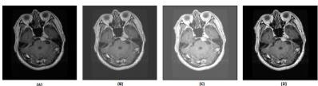

*Figure 1 Image enhancement using fuzzy logic:*

* Dark pixels are made darker, and bright pixels are made brighter.
* A rule-based system (e.g., *IF pixel is dark THEN output is very dark*) adjusts pixel values.
* The enhanced image is reconstructed and converted back to RGB.

This step helps in improving the visibility of tumor regions, leading to better feature extraction.

Dark pixels are made darker, and bright pixels are made brighter: This describes a contrast enhancement technique. By increasing the difference between dark and bright areas, the overall contrast of the image is amplified, potentially making details more discernible. The specific mathematical function used to achieve this can vary. For instance, a power-law transformation (gamma correction) with a gamma value greater than 1 will have this effect. Alternatively, a piecewise linear function could be designed to specifically target and stretch the intensity ranges of dark and bright pixels. The extent to which dark pixels are darkened and bright pixels are brightened will significantly impact the final appearance of the enhanced image.

A rule-based system (e.g., IF pixel is dark THEN output is very dark) adjusts pixel values: This introduces a more structured and potentially non-linear way of manipulating pixel intensities. Rule-based systems offer flexibility in how the enhancement is applied. The example you provided is a simple thresholding-like rule. More complex rules could involve multiple conditions, consider neighboring pixel values, or even incorporate knowledge about the image content. For example, rules could be designed to enhance specific features or suppress noise based on pixel intensity characteristics. The design of these rules is critical and often requires domain expertise or experimentation to achieve the desired outcome.

The enhanced image is reconstructed and converted back to RGB: This implies that the initial processing might have been done in a different color space or on individual color channels (Red, Green, Blue). Many image enhancement techniques are applied to the luminance or intensity component of an image (e.g., in HSV or Lab color spaces) to avoid introducing color distortions. After the enhancement is performed on this component, the image needs to be reconstructed back into the original RGB color space for display or further use. The conversion process needs to be handled correctly to maintain the integrity of the enhanced image's colors.

**The specific rules used:** What are the exact rules in the rule-based system? Are there thresholds involved? Are the output values fixed or dependent on the input value in a more continuous way?

The color space used for enhancement: Was the enhancement done on individual RGB channels or a different color space like HSV, HSL, or Lab? Why was that specific color space chosen?

## Deep Feature Extraction Using DBIRA2.0

The **DBIRA2.0** model is a deep CNN that combines:

* **Inception blocks** (from GoogleNet) – extract features at multiple scales using different kernel sizes (1×1, 3×3, 5×5).
* **Residual connections** (from ResNet) – avoid vanishing gradient and preserve information across layers.

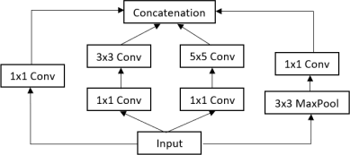

*Figure 2 The Inception block*

This architecture helps in capturing both local and global features of brain tumor images. Key features:

* Flatten pooling layer converts 2D feature maps into 1D vectors.
* Descriptors are extracted from multiple intermediate layers for rich representation.

## Reinforcement Learning Framework

The classification and retrieval task is framed as a **sequential decision-making problem** using Reinforcement Learning (RL):

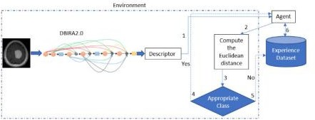

*Figure 3 The architecture of the proposed model: DBIRA2.0-RLN.*

* **Environment**: Consists of the image dataset.
* **Agent**: Learns to classify and retrieve similar images using KNN and Euclidean/Hamming distance.
* **State**: Feature descriptors of the current image.
* **Action**: Retrieve and classify the most similar image.
* **Reward**: Based on how close the retrieved images are to the query image (lower distance = higher reward).
* **Policy**: Boltzmann exploration policy is used to decide actions.
* **Experience Replay**: Stores past results to improve learning over time.

## Dimensionality Reduction using MPCA

Instead of using traditional PCA, the **Multilinear Principal Component Analysis (MPCA)** is applied

directly to the 3D tensor descriptors:

* Maintains the spatial structure of the image.
* Reduces computational load and storage.
* Converts high-dimensional data into a compressed yet informative format.

## Binary Descriptor Generation

To further optimize retrieval:

* Compressed descriptors are converted into **binary hash codes**.
* These codes allow fast image search using **Hamming distance**.
* Only top-5 most similar images are returned for each test image.

## Evaluation Setup

* Dataset: 7023 MRI brain images (glioma, meningioma, pituitary, and no tumor).
* Split: 81% training, 19% testing.

Tools: TensorFlow, Python Gym (for RL environment).

* Metrics: Classification Accuracy, mAP (mean Average Precision), Inference Time, PSNR (for image enhancement).

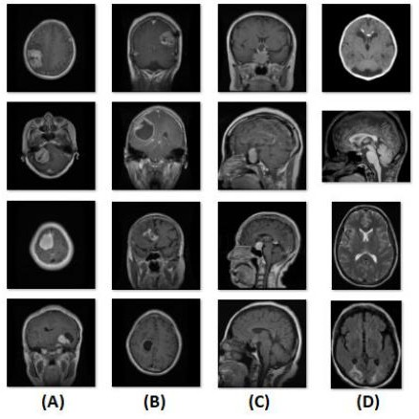

*Figure 4 Sample dataset images; (A) Meningioma tumor, (B) Glioma,(C) Pituitary tumor,(D)No Tumor*

## System Flow Diagram

**Input MRI Image**

**↓**

**Fuzzy Image Enhancement (FIS)**

**↓**

**Feature Extraction (DBIRA2.0)**

**↓**

**MPCA for Dimensionality Reduction**

**↓**

**Binary Descriptor Encoding**

**↓ Reinforcement Learning Agent**

**↓**

**Top-5 Image Retrieval & Classification**

# CHAPTER 6

**RESULTS**

This chapter presents the experimental outcomes of the proposed **DBIRA2.0-RLN** and its enhanced version with MPCA. Various evaluation metrics such as classification accuracy, mean Average Precision (mAP), PSNR, and inference time were used to measure the performance of the system on brain tumor classification and retrieval tasks.

* 1. **Dataset Used**

This additional information provides valuable context about the dataset used for evaluating the MRI brain tumor classification system. Here's a breakdown of what we can infer and what further questions arise:

**Key Observations:**

* **Dataset Size and Class Distribution:** The dataset of 7023 MRI brain images appears reasonably large, which is generally beneficial for training robust machine learning models, especially deep learning architectures. The distribution of images across the four classes (glioma, meningioma, pituitary tumor, and no tumor) is relatively balanced. While there's a slight variation, no single class dramatically outweighs the others. This balance is positive as it reduces the risk of a model being heavily biased towards the majority class.
* **Data Split Strategy:** The chosen data split of 81% for training and 19% for testing is a common practice. The larger training set allows the model to learn the underlying patterns in the data, while the separate testing set provides an independent evaluation of the model's generalization ability on unseen data. This helps to assess whether the model has truly learned to classify tumors or has simply memorized the training data.
* **Data coStrategy:** The chosen data split of 81% for training and 19% for testing is a common practice. The larger training set allows the model to learn the underlying patterns in the data, while the separate testing set provides an independent evaluation of the model's generalization ability on unseen data. This helps to assess whether the model has truly learned to classify tumors or has simply memorized the training data.
  + - Total images: **7023 MRI brain images**
      * Glioma Tumor: 1621
      * Meningioma Tumor: 1645
      * Pituitary Tumor: 1757
      * No Tumor: 2000
    - Data split:
      * **Training set:** 81%
      * **Testing set:** 19%
  1. **Image Enhancement Results**

The proposed **Fuzzy Inference System (FIS)** was evaluated against traditional methods like Histogram Equalization (HE) and CLAHE.

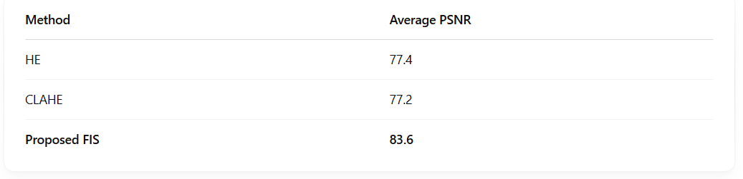

*Figure 6.1 The proposed FIS achieved the highest PSNR, proving it enhances MRI image quality without introducing visual artifacts.*

## Classification Accura

## 

Figure 6.2 BIRA2.0-RLN (Initial Model

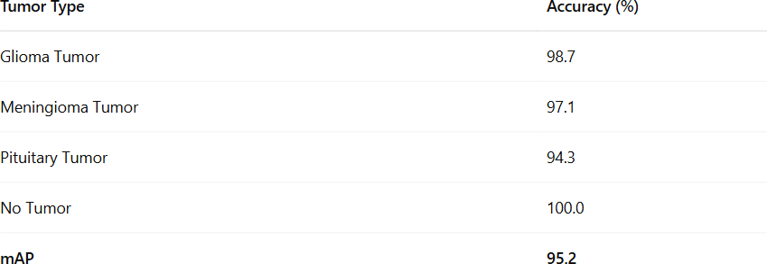

*Figure 6.3 Enhanced DBIRA2.0-RLN (with MPCA)*

* 1. **Confusion Matrix Analysis**

Using the enhanced DBIRA2.0-RLN model, the confusion matrix clearly shows high classification performance with almost zero misclassification in “No Tumor” and very low confusion in tumor categories.

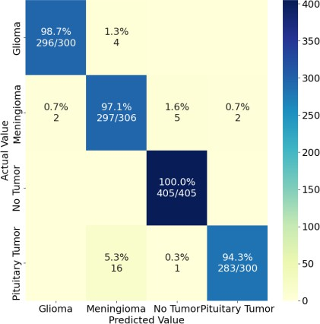

Figure 5Confusion matrix of enhanced DBIRA2.0-RLN

## Comparison with Other Models

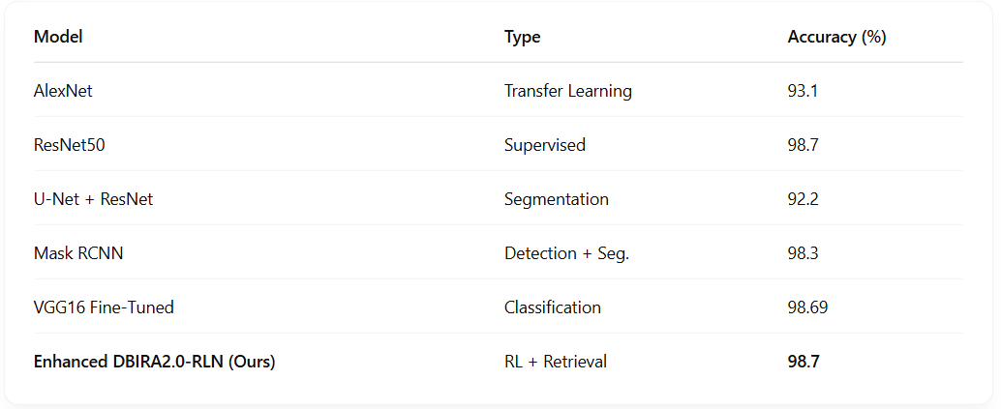

*Figure 6Comparison with Other Models*

Our model is the only one combining classification **and retrieval** through a **reinforcement learning agent**—a major innovation over others.

## Summary of Results

* + - **Highest classification accuracy: 98.7% (Enhanced DBIRA2.0-RLN)**
    - **Perfect accuracy on “No Tumor” class**
    - **Best image enhancement quality: PSNR = 83.6**
    - **Fast and accurate retrieval with binary descriptors**
    - **Outperforms both traditional ML and popular DL models**

# CHAPTER 7

## Conclusion

# CONCLUSION AND FUTURE ENHANCEMENT

In this study, a novel and intelligent framework—**DBIRA2.0-RLN (Deep Brain Incep Res Architecture 2.0 - Reinforcement Learning Network)**—was proposed for the classification and retrieval of brain tumor images using MRI scans. The model effectively integrates multiple technologies: **fuzzy logic for image enhancement**, **deep convolutional layers for feature extraction**, **reinforcement learning for dynamic decision-making**, and **Multilinear PCA for dimensionality reduction and retrieval optimization**.

The model was trained and tested on a real-world dataset of 7023 brain MRI images and achieved impressive results, including:

* + - **Classification Accuracy:** Up to **98.7%**
    - **Mean Average Precision (mAP):** Up to **95.2%**
    - **Image Enhancement:** Superior PSNR score using fuzzy logic-based preprocessing
    - **Effective Top-5 Retrieval** of similar images using binary hash-coded descriptors

Compared to conventional supervised models like AlexNet, VGG16, ResNet, and segmentation networks like U-Net or Mask-RCNN, the proposed DBIRA2.0-RLN not only provides **high classification accuracy** but also supports **intelligent image retrieval**—a feature missing in many existing systems.

The use of **reinforcement learning** enables the model to adaptively learn from previous experiences, improving over time without retraining from scratch. This makes the system robust and suitable for real- time clinical settings where continuous learning is valuable.

## Future Enhancements

Although the proposed model achieved high performance, there are several avenues for future improvement:

1. **Expand Dataset Size and Diversity**

Future work can incorporate more diverse MRI datasets from multiple sources and institutions, including multi-modal MRI images (e.g., T1, T2, FLAIR) for better generalization and robustness.

1. **3D Brain MRI Analysis**

Current implementation uses 2D image slices. Extending the model to handle **3D volumetric data** can capture spatial context and improve diagnosis accuracy.

1. **Tumor Localization and Segmentation**

Integration of a segmentation module could help not just in classification but also in **identifying tumor boundaries**. This is crucial for treatment planning and surgery.

1. **Cloud/Edge Deployment for Clinical Use**

Deploying the system as a **web app or mobile interface** can make it more accessible to hospitals, clinics, and radiologists for real-time diagnosis support.

1. **Model Compression and Optimization**

Since medical systems need to work efficiently on limited hardware, model pruning and quantization techniques can be applied for faster inference and lower memory consumption.

1. **Explainability in AI (XAI)**

Implementing explainable AI techniques like **Grad-CAM or LIME** can provide visual justifications for model predictions, increasing trust among clinicians.

1. **Integration with Patient Records and Decision Systems**

The system can be enhanced by combining image-based diagnosis with patient clinical data (age, symptoms, history) for a more **holistic and personalized diagnosis**.

**REFERENCES**

[1] Z. Yao, X. Liang, G.-P. Jiang, and J. Yao, ‘‘Model-based reinforcement learning control of electrohydraulic position servo systems,’’ IEEE/ASME Trans. Mechatronics, vol. 28, no. 3, pp. 1446–1455, Jun. 2023.

[2] G. S. Tandel, A. Tiwari, and O. G. Kakde, ‘‘Performance optimisation of deep learning models using majority voting algorithm for brain tumour classification,’’ Comput. Biol. Med., vol. 135, Aug. 2021, Art. no. 104564, doi: 10.1016/j.compbiomed.2021.104564.

[3] K. R. Pedada, R. A. Bhujanga, K. K. Patro, J. P. Allam, M. M. Jamjoom, and N. A. Samee, ‘‘A novel approach for brain tumour detection using deep learning based technique,’’ Biomed. Signal Process. Control, vol. 82, Apr. 2023, Art. no. 104549, doi: 10.1016/j.bspc.2022.104549.

[4] A. S. M. Shafi, M. B. Rahman, T. Anwar, R. S. Halder, and H. M. E. Kays, ‘‘Classification of brain tumors and auto-immune disease using ensemble learning,’’ Informat. Med. Unlocked, vol. 24, May 2021, Art. no. 100608, doi: 10.1016/j.imu.2021.100608.

[5] R. Mehrotra, M. A. Ansari, R. Agrawal, and R. S. Anand, ‘‘A transfer learning approach for AI-based classification of brain tumors,’’ Mach. Learn. With Appl., vol. 2, Dec. 2020, Art. no. 100003, doi: 10.1016/j.mlwa.2020.100003.

[6] A. Rehman, S. Naz, M. I. Razzak, F. Akram, and M. Imran, ‘‘A deep learning-based framework for automatic brain tumors classification using transfer learning,’’ Circuits, Syst., Signal Process., vol. 39, no. 2, pp. 757–775, Sep. 2019, doi: 10.1007/s00034-019-01246-3.

[7] K. U. Devi and R. Gomathi, ‘‘Convolutional neural network based brain tumor classification using robust background saliency detection,’’ J. Med. Imag. Health Informat., vol. 11, no. 10, pp. 2610–2617, Oct. 2021, doi: 10.1166/jmihi.2021.3849.

[8] A. H. Khan, S. Abbas, M. A. Khan, U. Farooq, W. A. Khan, S. Y. Siddiqui, and A. Ahmad, ‘‘Intelligent model for brain tumor identification using deep learning,’’ Appl. Comput. Intell. Soft Comput., vol. 2022, pp. 1–10, Jan. 2022, doi: 10.1155/2022/8104054.

[9] K. Srilatha, P. Chitra, M. Sumathi, M. S. Sanju. I, and F. V. Jayasudha, ‘‘Automated MRI brain tumour segmentation and classification based on deep learning techniques,’’ in Proc. 2nd Int. Conf. Adv. Electr., Comput., Commun. Sustain. Technol. (ICAECT), Apr. 2022, pp. 1–6, doi: